Ethics and net zero healthcare
Anand Bhopal, background paper: PS 1.1 "Climate Injustice: Ethics, Distributions, Fairness, and Justice"
Climate change is a major threat to health, health services and poverty alleviation, however, healthcare is also responsible for 5.2% of global greenhouse gas emissions (1), which is more than major polluting industries such as aviation and shipping . The roughly proportional relationship between greenhouse gas emissions and global temperature rise means that healthcare is independently and quantifiably contributing to increasing the health impacts of climate change (2,3). Although policy makers are accustomed to targets – namely 1.5°C and 2°C - determining the ‘right’ temperature threshold to aim for and accompanying levels of emissions mitigation required is largely an ethical question, rather than a scientific one. While a growing body of research is examining the carbon footprint of healthcare at both the micro (4) to macro level (5,6), relatively little has been written about how to fairly reach net zero healthcare globally. Emissions incur benefits and inflict harm. Decarbonisation can save money and improve health but at some level it inescapably involves trade-offs. In this background paper I will briefly set out ideas on how to fairly share costs and benefits on the path to net zero, focusing on the example of decarbonising healthcare. Detail will be provided during the presentation.

Inequality and net zero
How to assign responsibility for mitigation, value the health impacts of climate change and compensate for loss and damage are all critical issues for climate action which present a major headache for policy makers (7). Solutions considered to be fairer are also generally deemed less politically feasible; those deemed politically feasible, inadequate (8). Over the course of 30 years of high level international climate summits (‘COPs’ or Conference of Parties), emissions have steadily risen; rising, after a brief pandemic dip, to an all-time high. The remaining carbon budget to stay within the Paris Agreement – the intergovernmental agreement to limit global temperature rise to 1.5°C - 2°C while pursuing poverty eradication and sustainable development – is rapidly diminishing (9).
Emissions are not shared equally. There are huge inequalities in emissions both within and between countries (Figure 1) with major implications for fairness (10). One recurring for policy makers is the idea that timely climate mitigation suffers from the ‘free-rider’ problem (11). While producing emissions imposes burdens on others (through increasing global temperatures), reducing emissions provide a benefit which everyone enjoys (through helping stabilise global temperatures), whether they reduce their own emissions or not (12). Put another way, the climate impacts are a ‘negative externality’, which has acted as an incentive to delay and minimise effective climate action out of so-called ‘rational self-interest’. Even the biggest polluters have historically insisted on not acting until others act, resulting in paralysis. This problem has been characterised by economist Nicholas Stern as “the greatest market failure the world has ever seen” (7,13).

Figure 1: Per capita emissions, by world region and income group (Data from: World Inequality Report, 2022 (14))
By contrast, climate adaptation, a critical consideration for the health policy makers in the coming decades, does not suffer from freeriding, nor does it impose costs on others. However, it is severely limited by financial constraints since adaptation is needed most amongst the global poor. Since carbon emissions are tightly linked to income, these individual also have the least responsibility for climate change. The challenge posed by cutting carbon emissions while pursuing sustainable development is evident in the case of poverty eradication.
At same time as reducing individuals’ vulnerability to climate impacts, alleviating poverty will increase the global mitigation effort required to stay below 1.5°-2°C. Currently, the additional emissions associated with eradicating extreme poverty ($1.9 PPP/day) would have a minimal impact on emissions, however, bringing everyone above the (still modest) level of $2.97 PPP/day would increase global temperatures by 0.6°C (15). This would have major implications for climate mitigation efforts globally – including what wealthy countries consider their ‘fair share’ of responsibility to cutting emissions. Since the remaining carbon budget to stay within 1.5° and 2°C is fixed (i.e. ‘zero sum’) poverty eradication and more generally sustainable development within planetary boundaries (16) would require significantly drastically scaling up mitigation efforts elsewhere.

Net zero healthcare ethics:
A breakthrough of the Paris Agreement has been to decentralise focus to cities, businesses and sectors - including healthcare - allowing more tailored solutions to emerge from the bottom up and decreasing dependence on political leaders reaching a deal. Over the last decade, the movement to decarbonise healthcare has gained ground, culminating in the launch of the WHO COP26 Health Programme in November 2021, which calls for countries to develop low-carbon, sustainable and climate resilient health systems. To date 55 countries have signed up, with 20 countries setting a specific date to reach net zero healthcare, with the majority of signatories are low- and middle-income countries (17). This reflects a mis-match given low- and middle-income countries are at highest risk from the health impacts of climate change, while the most polluting healthcare systems are in high-income countries (Figure 2).
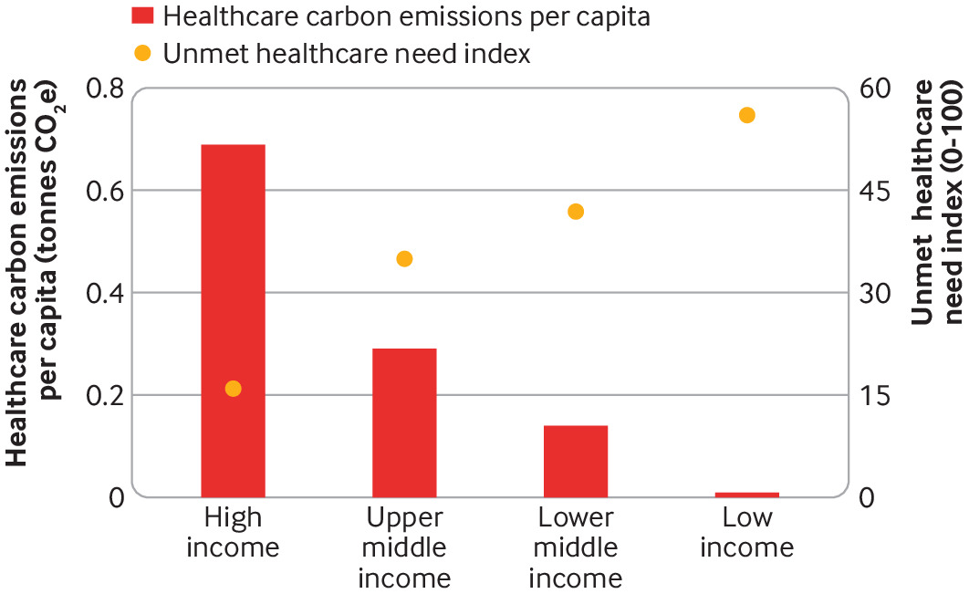
Fig 2 - Average healthcare carbon emissions per capita and unmet healthcare need by World Bank region (Figure from (18)).
Inequalities between and within countries are stark and a lot needs to be done to provide even basic healthcare for all, notwithstanding cutting emissions. For example, at present only 40%-72% of health facilities in low- and middle-income countries have reliable electricity and health facilities serving a billion people have no electricity at all (19). Though technically low-carbon, this is medically hazardous and morally unacceptable. At COP27 international agencies committed to support electrifying 100,000 health facilities by 2030 which, though an important step, still represents a fraction of the 415,000 new health facilities estimated to be needed to achieve SDG 3. The process of electrifying health facilities represents a vital opportunity to install renewable energy capacity and avoid high-carbon lock in further down the line; fair financing to support this investment is critical.
By contrast, carbon emissions in the European Union associated with healthcare overconsumption (i.e. healthcare with no clinical benefit) have been estimated to exceed total healthcare carbon emissions in sub-Saharan Africa, a region double its population size (18). In the face of a limited and rapidly diminishing carbon budget, a global effort to decarbonise healthcare must reduce waste, set priorities and make trade-offs. The gulf between rich and poor cannot be overlooked. This involves value judgements: whose interests count and whose don’t; how to compensate those who are harmed; and how to finance net zero healthcare globally. In turn this reflects who has power to set the agenda and control financing. As efforts to decarbonise healthcare shift from conceptualisation to implementation it is crucial that policy makers work to ensure that pathways to net zero are holistic and fair.

Conclusion:
Net zero is a scientific target which is underpinned by ethical values. Put simply, inequality in income and emissions are inextricably tied to fair pathways to net zero healthcare. As a growing number of countries pursue healthcare sector specific decarbonisation strategies it is critical that ethical considerations receive greater attention from researchers and policy makers alike.
Further details and analysis on fair pathways to net zero healthcare will be provided during the conference presentation during the Prince Mahidol Conference 2023. PS 1.1 " Climate Injustice: Ethics, Distributions, Fairness, and Justice " on Friday 27 January 2023 from 14:00 - 16:00.

References

1. Romanello M, Napoli CD, Drummond P, Green C, Kennard H, Lampard P, et al. The 2022 report of the Lancet Countdown on health and climate change: health at the mercy of fossil fuels. The Lancet [Internet]. 2022 Oct 25;0(0). Available from: https://www.thelancet.com/journals/lancet/article/PIIS0140-6736(22)01540-9/fulltext
2. Bressler RD. The mortality cost of carbon. Nat Commun [Internet]. 2021 Jul 29;12(1):1–12. Available from: https://www.nature.com/articles/s41467-021-24487-w
3. Sharma S, Bressler RD, Bhopal A, Norheim OF. The global temperature-related mortality impact of earlier decarbonization for the Australian health sector and economy: A modelling study. PLOS ONE [Internet]. 2022 Aug 3;17(8):e0271550. Available from: https://journals.plos.org/plosone/article?id=10.1371/journal.pone.0271550
4. Drew J, Christie SD, Rainham D, Rizan C. HealthcareLCA: an open-access living database of health-care environmental impact assessments. Lancet Planet Health [Internet]. 2022 Dec 1;6(12):e1000–12. Available from: https://www.thelancet.com/journals/lanplh/article/PIIS2542-5196(22)00257-1/abstract
5. Lenzen M, Malik A, Li M, Fry J, Weisz H, Pichler PP, et al. The environmental footprint of health care: a global assessment. Lancet Planet Health [Internet]. 2020 Jul 1;4(7):e271–9. Available from: https://www.thelancet.com/journals/lanplh/article/PIIS2542-5196(20)30121-2/abstract
6. Pichler PP, Jaccard IS, Weisz U, Weisz H. International comparison of health care carbon footprints. Environ Res Lett [Internet]. 2019 May [cited 2020 May 12];14(6):064004. Available from: https://doi.org/10.1088%2F1748-9326%2Fab19e1
7. Stern N, Taylor JS in collaboration with C. The economics of immense risk, urgent action and radical change: towards new approaches to the economics of climate change. J Econ Methodol [Internet]. 2022 Feb 24 [cited 2022 Jun 22];0(0):1–36. Available from: https://doi.org/10.1080/1350178X.2022.2040740
8. Matthews HD, Tokarska KB, Nicholls ZRJ, Rogelj J, Canadell JG, Friedlingstein P, et al. Opportunities and challenges in using remaining carbon budgets to guide climate policy. Nat Geosci [Internet]. 2020 Dec;13(12):769–79. Available from: https://www.nature.com/articles/s41561-020-00663-3
9. Mercator Research Institute on Global Commons and Climate Change. Remaining carbon budget [Internet]. 2021 [cited 2021 Jan 29]. Available from: https://www.mcc-berlin.net/en/research/co2-budget.html
10. Williges K, Meyer LH, Steininger KW, Kirchengast G. Fairness critically conditions the carbon budget allocation across countries. Glob Environ Change [Internet]. 2022 May 1 [cited 2022 Dec 21];74:102481. Available from: https://www.sciencedirect.com/science/article/pii/S095937802200019X
11. Ostrom E. A Polycentric Approach for Coping with Climate Change: Background Paper to the 2010 World Development Report (Policy Research Working Paper 5095). Washington DC: World Bank; 2010.
12. Intergovernmental Panel on Climate Change. Climate Change 2014: Mitigation of Climate Change. Contribution of Working Group III to the Fifth Assessment Report of the Intergovernmental Panel on Climate Change. Cambridge University Press; 2014. 1554 p.
13. Stern N, Stern NH, Treasury GB. The Economics of Climate Change: The Stern Review. Cambridge University Press; 2007. 645 p.
14. Chancel L, Piketty T, Saez E, Zucman G. World Inequality Report 2022. World Inequality Lab; 2022.
15. Hubacek K, Baiocchi G, Feng K, Patwardhan A. Poverty eradication in a carbon constrained world. Nat Commun [Internet]. 2017 Oct 24;8(1):912. Available from: https://www.nature.com/articles/s41467-017-00919-4
16. O’Neill DW, Fanning AL, Lamb WF, Steinberger JK. A good life for all within planetary boundaries. Nat Sustain [Internet]. 2018 Feb;1(2):88–95. Available from: https://www.nature.com/articles/s41893-018-0021-4
17. World Health Organisation. COP26 Health Programme: Country Commitments [Internet]. 2022. Available from: https://www.who.int/initiatives/alliance-for-transformative-action-on-climate-and-health/country-commitments
18. Bhopal A, Norheim OF. Priority setting and net zero healthcare: how much health can a tonne of carbon buy? BMJ [Internet]. 2021 Oct 28;375:e067199. Available from: https://www.bmj.com/content/375/bmj-2021-067199
19. WHO. Energizing health: accelerating electricity access in health-care facilities [Internet]. Geneva; 2023. Available from: https://www.who.int/publications/i/item/energizing-health--accelerating-electricity-access-in-health-care-facilities

